Snapshot Step by Step for Project 2

Step 1: Docker

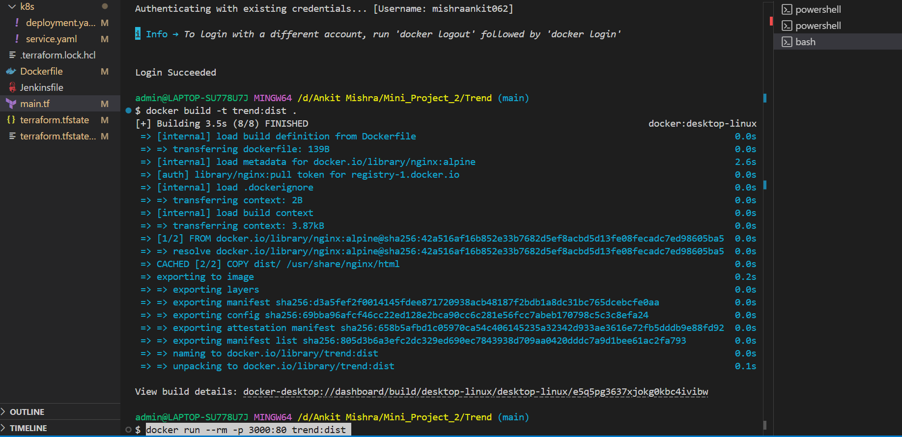

1.Building an application using Docker file.

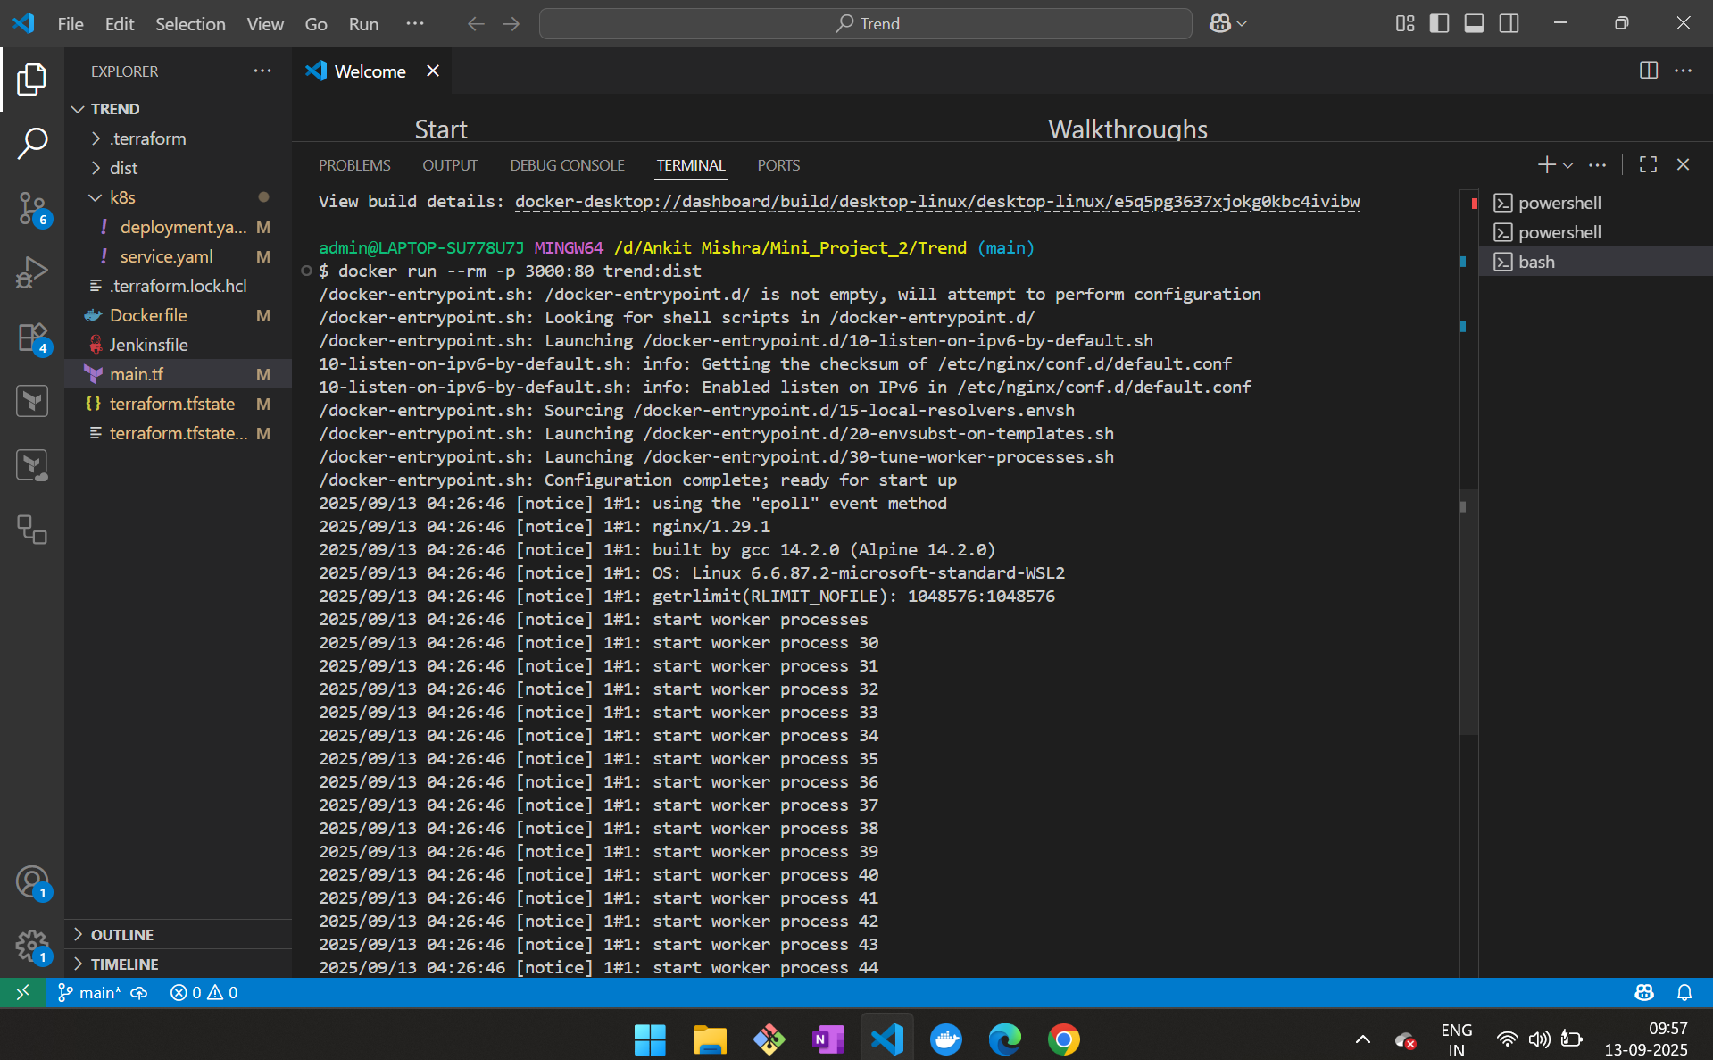

2.Running Docker file in local system



3.Project running in local system

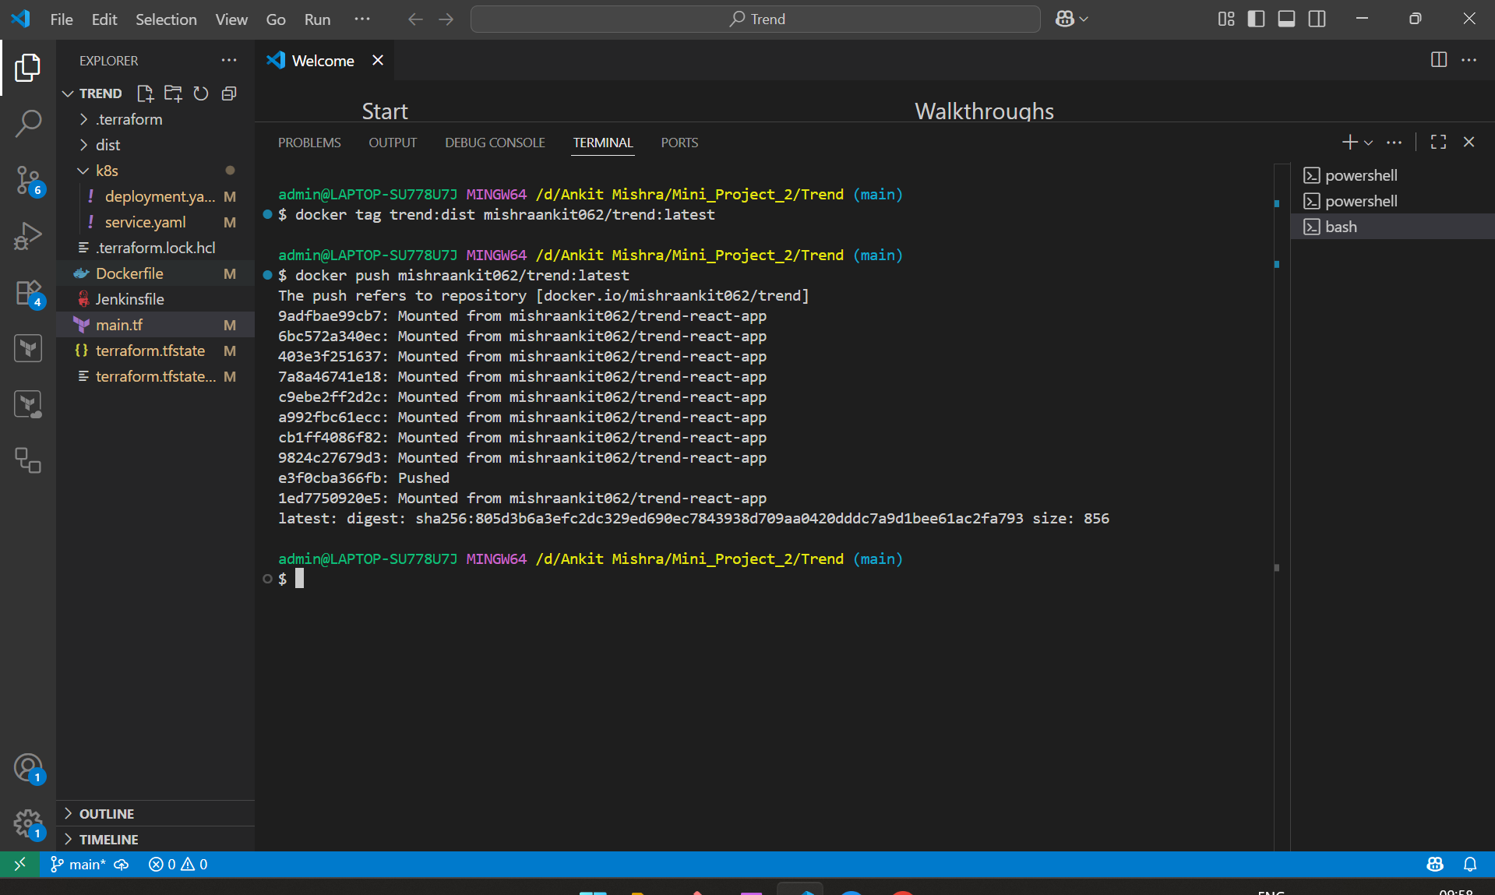

4.Pushing the Docker image to Docker hub Repo

Step2: **Terraform**

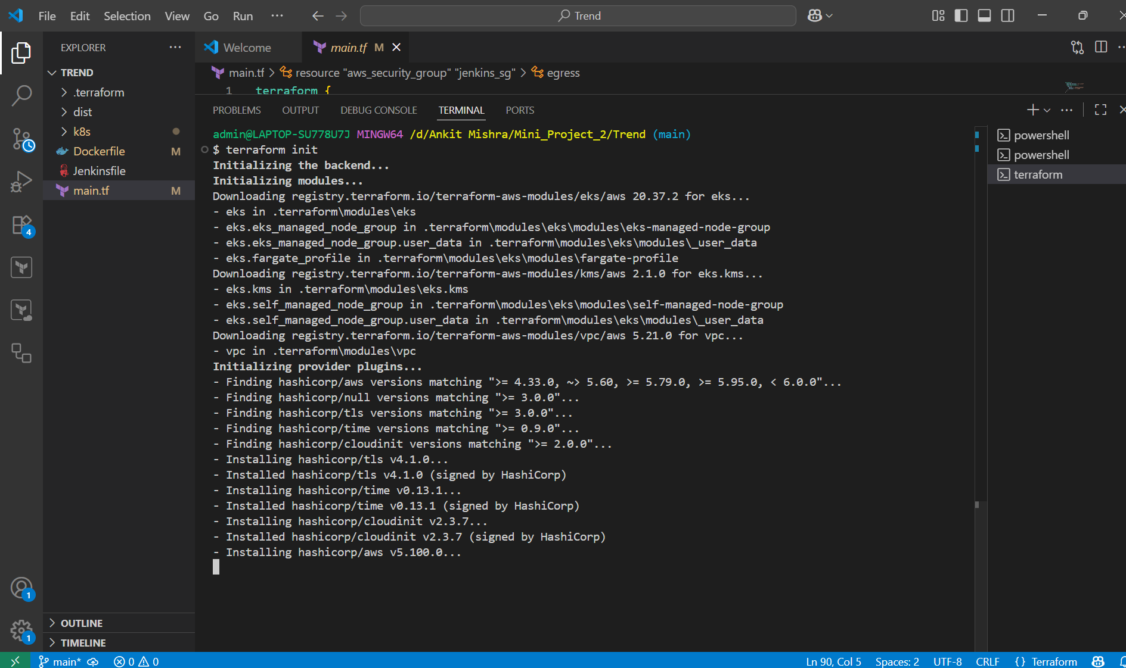

5. **Initializing terraform**

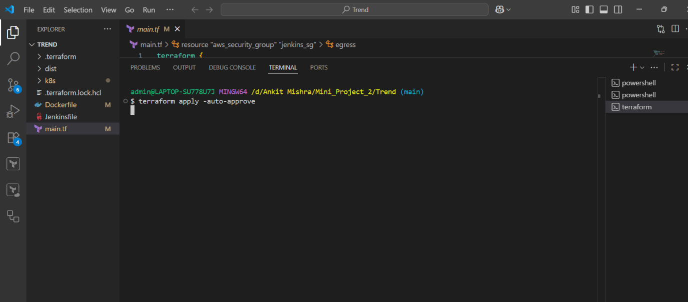

**6.1. Applying terraform so terraform code get initiated**

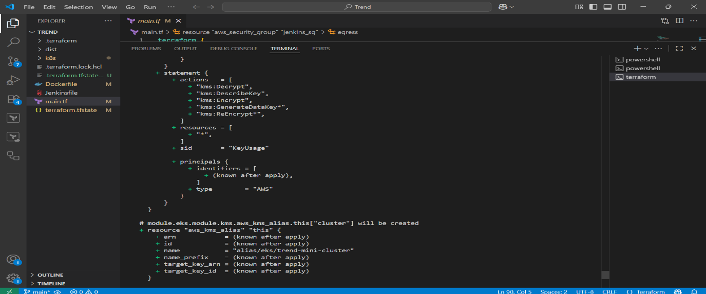

**6.2**

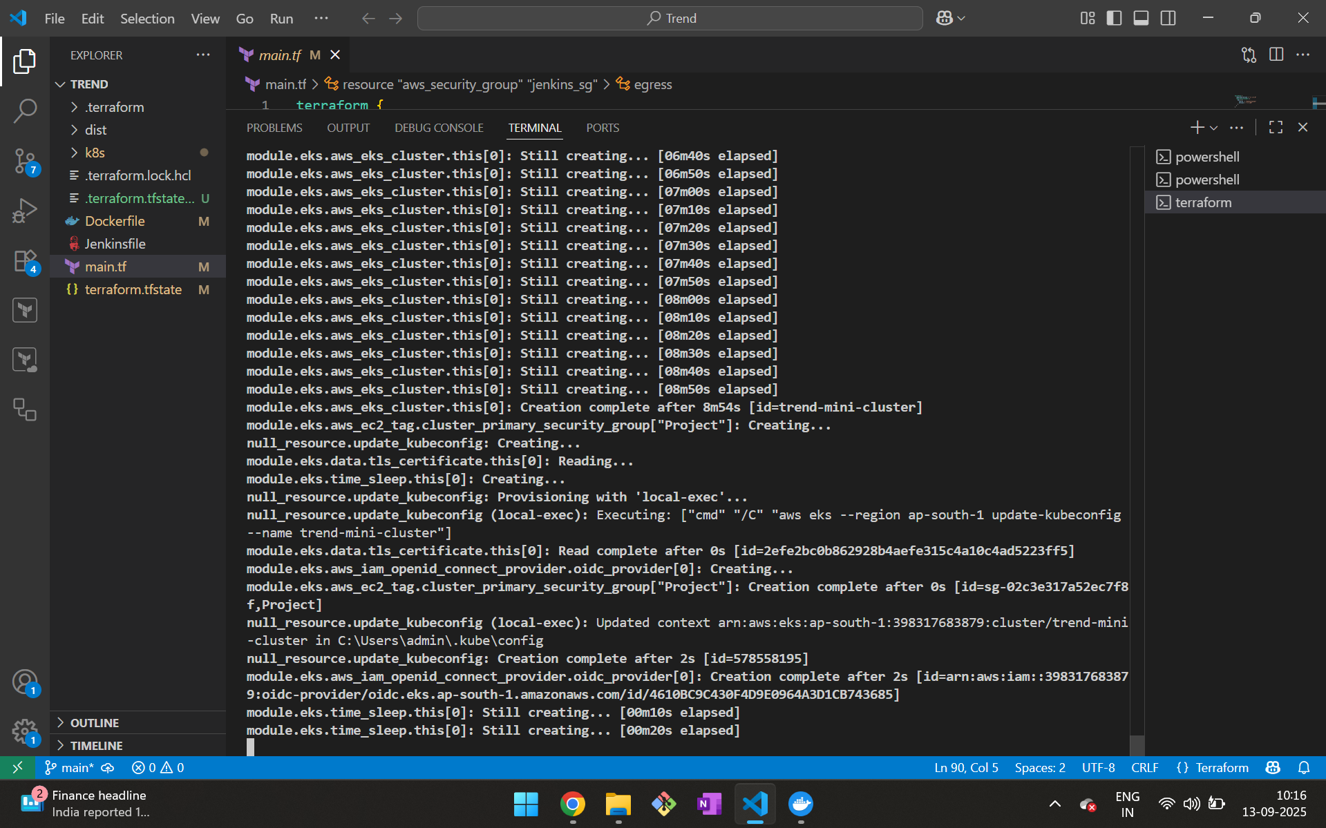

**6.3**

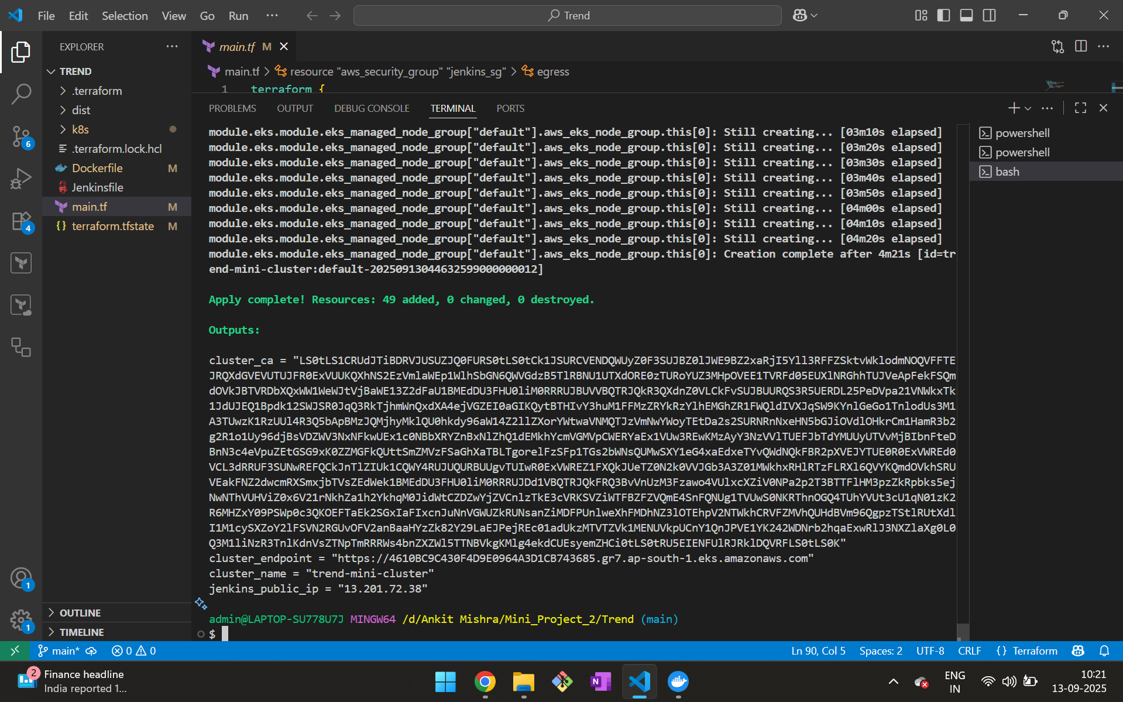

**6.6. Code get initiated and machine is created in aws account**

**Step3: Kubernetes**

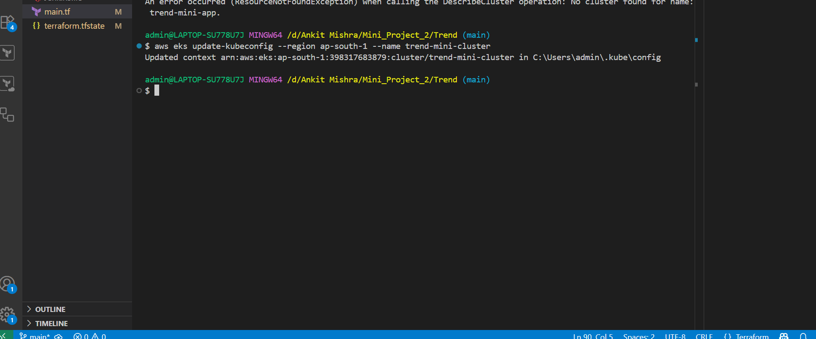

**7. Setup for Kubernetes and provide name for the cluster**

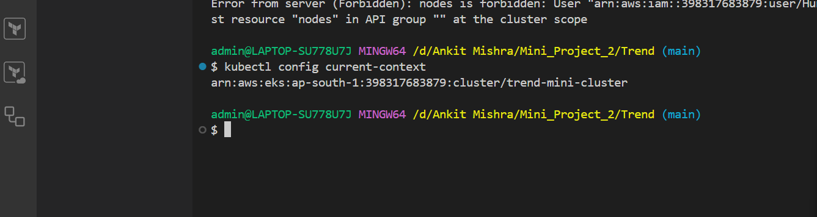

**8. Checking arn created**

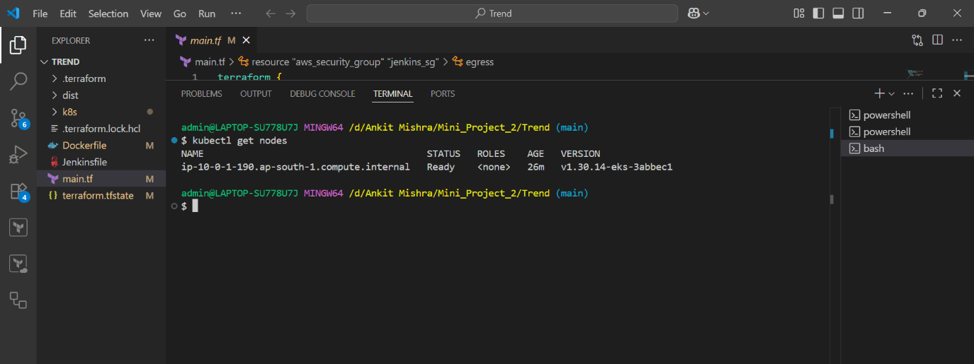

**9. Status of nodes**

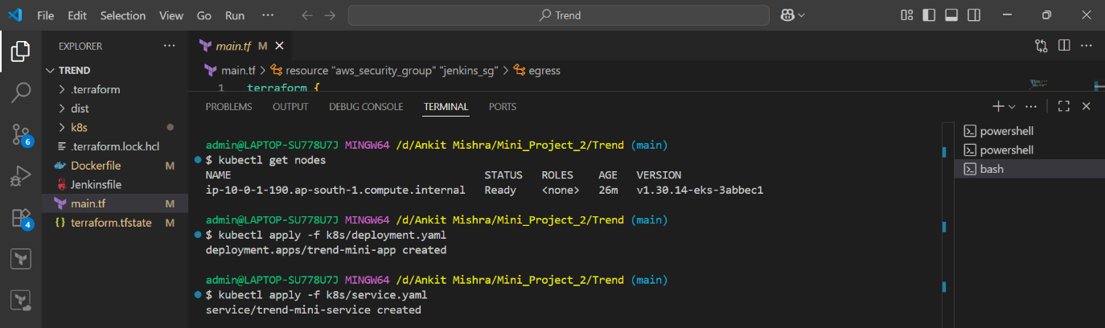

**10. Running cmd deployment and service yml files**

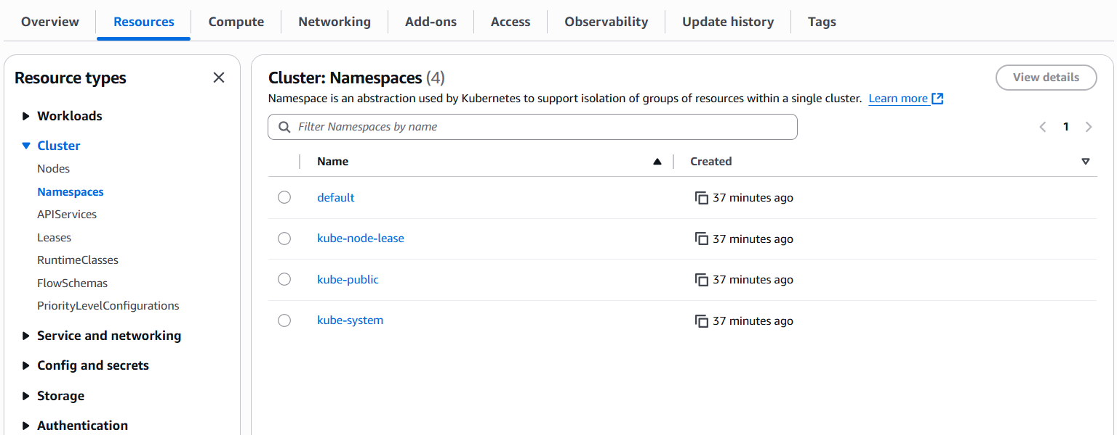

**11. nodes created in aws account**

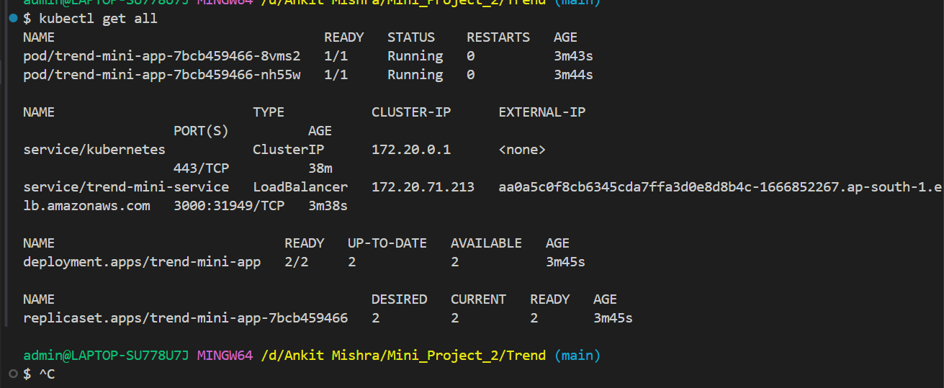

**12.all info about running nodes and cluster.**

**Step5: Jenkins**

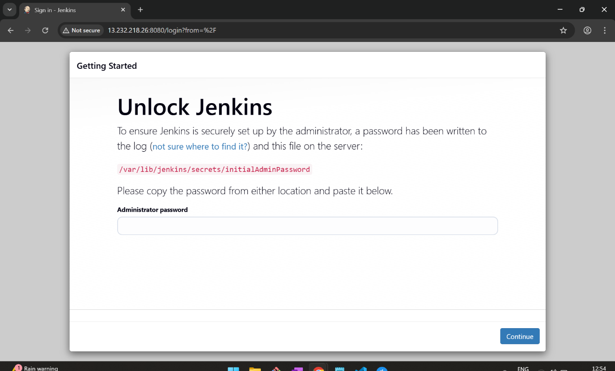

**12. Jenkins installed In Ec2 machine ready to Crete an account**

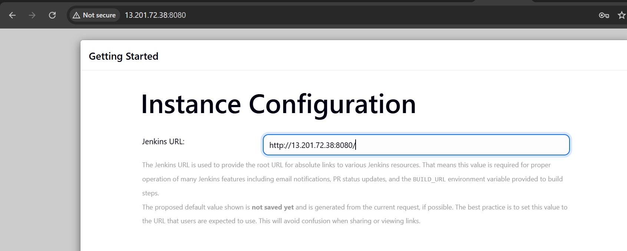

**12.1**

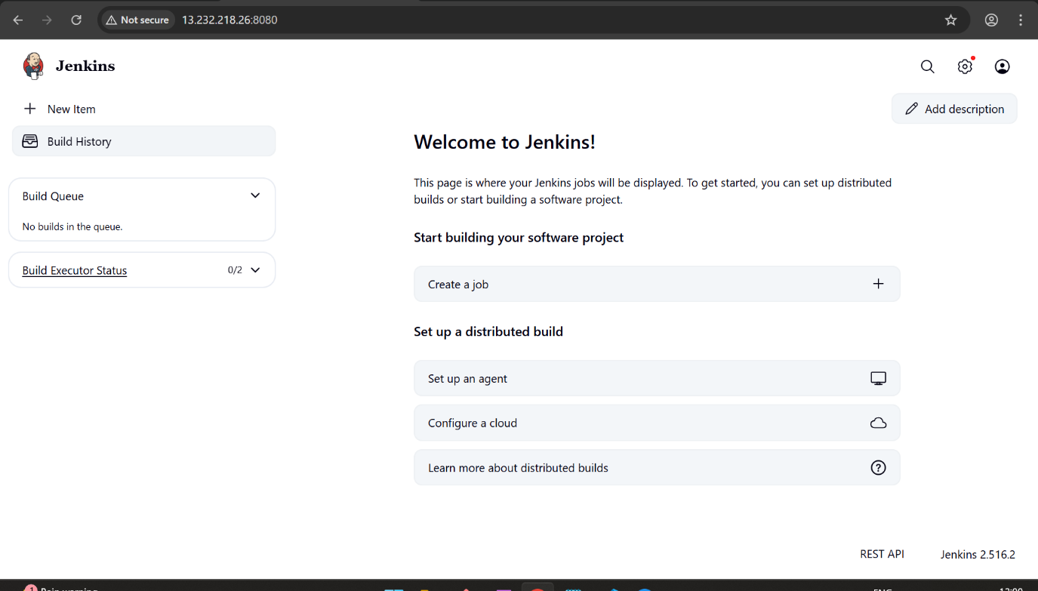

**13. Home page of Jenkins page after account get created**

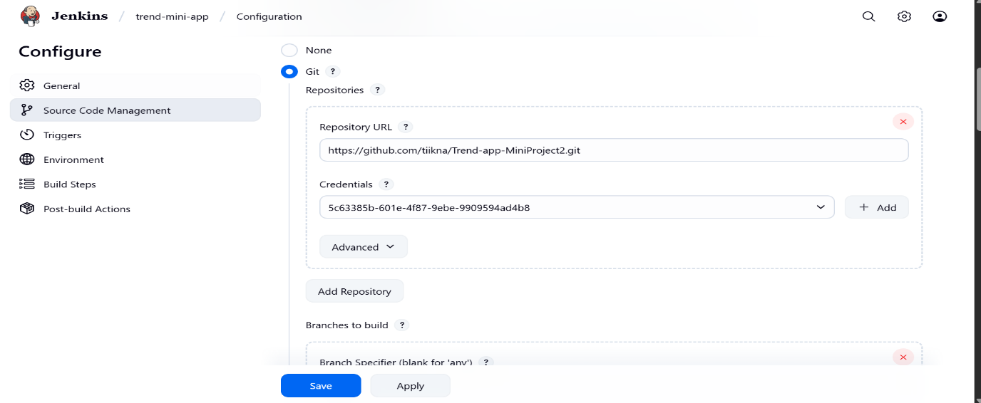

**14. GitHub and Jenkins integration using GitHub webhook**

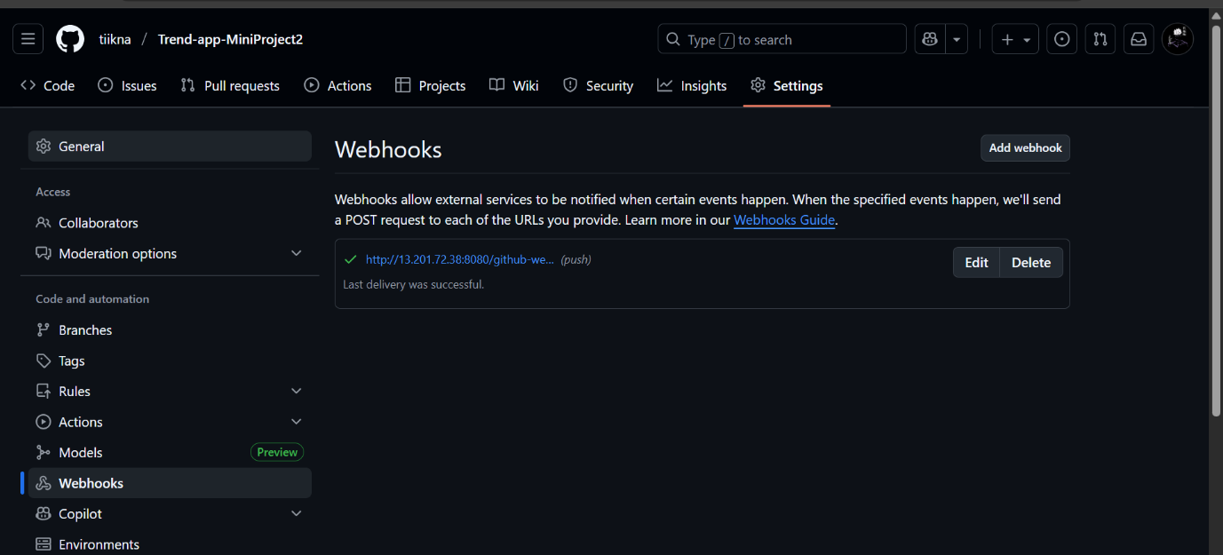

**14.1**

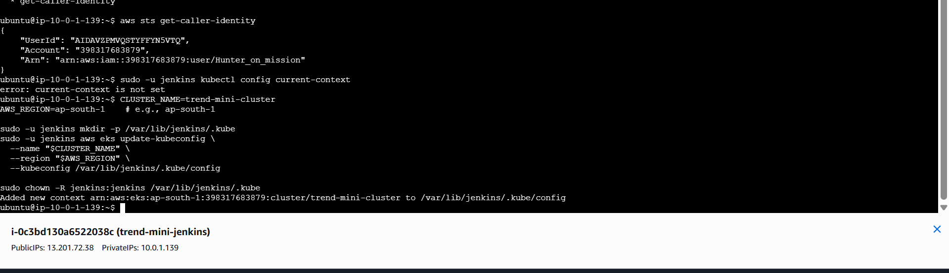

**15. Configuring kube config in EC2 machine where Jenkins is running**

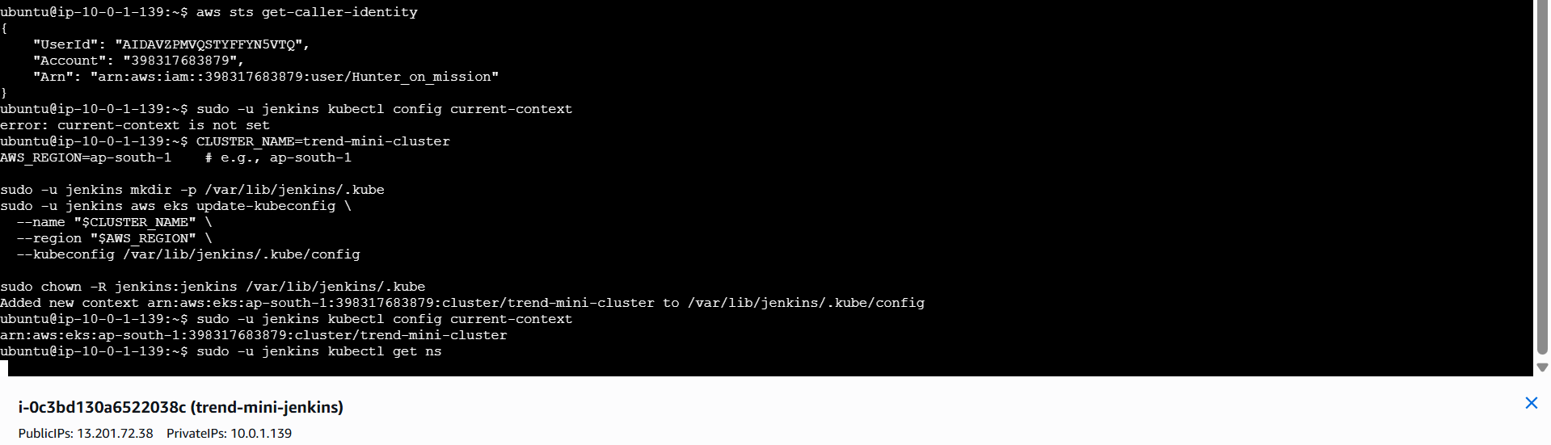

**15.1**

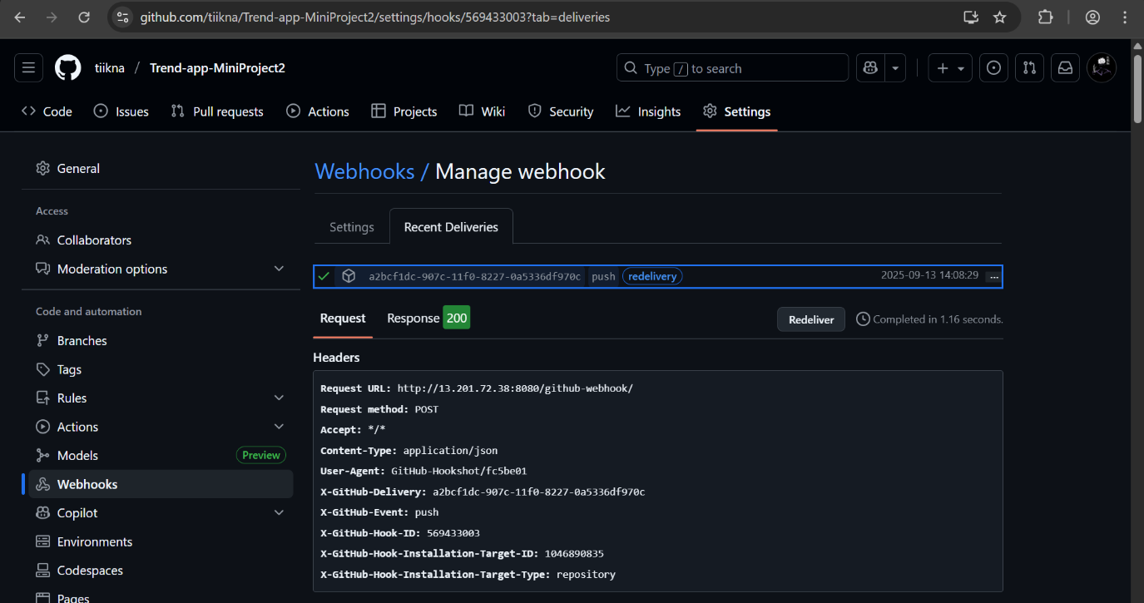

**16. webhook trigger in GitHub script get executed**

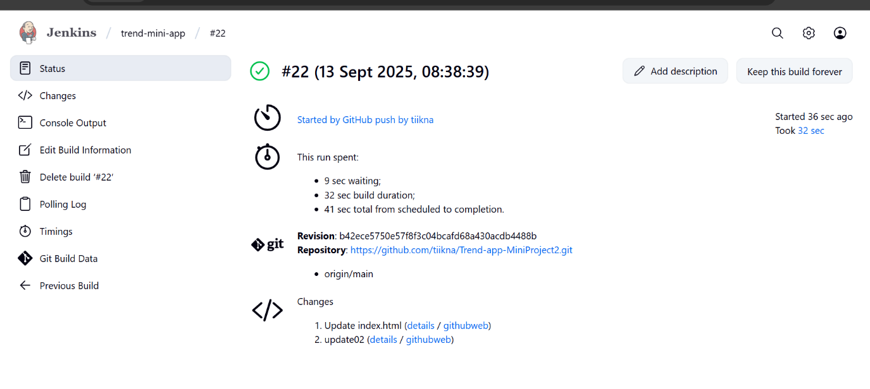

**17.Jenkins pipeline script successfully run**

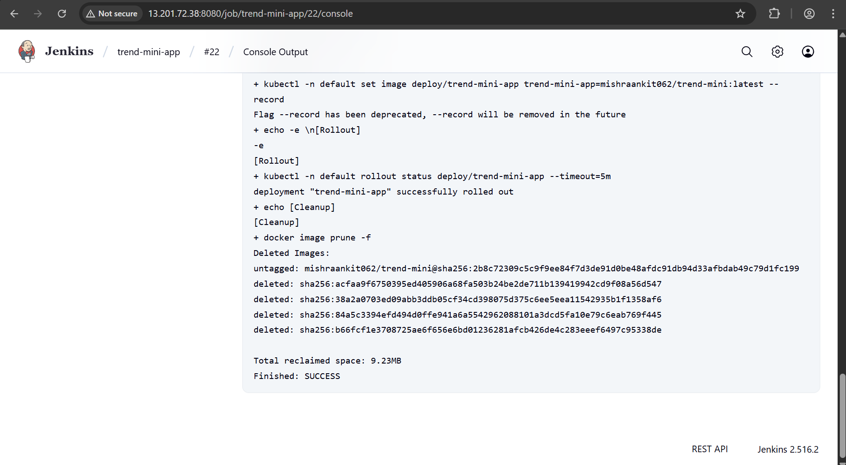

**17.1**

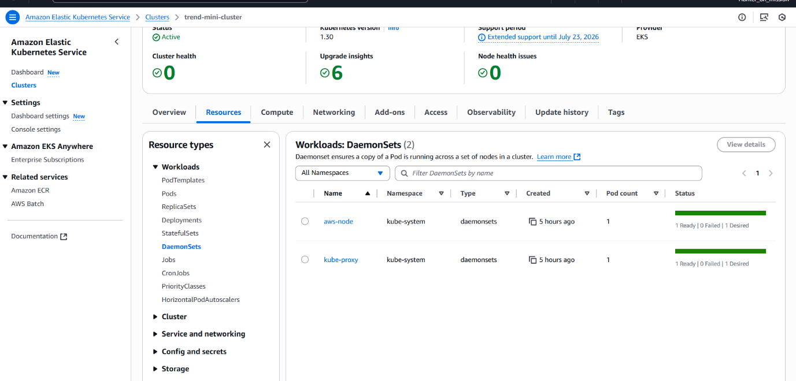

**18. 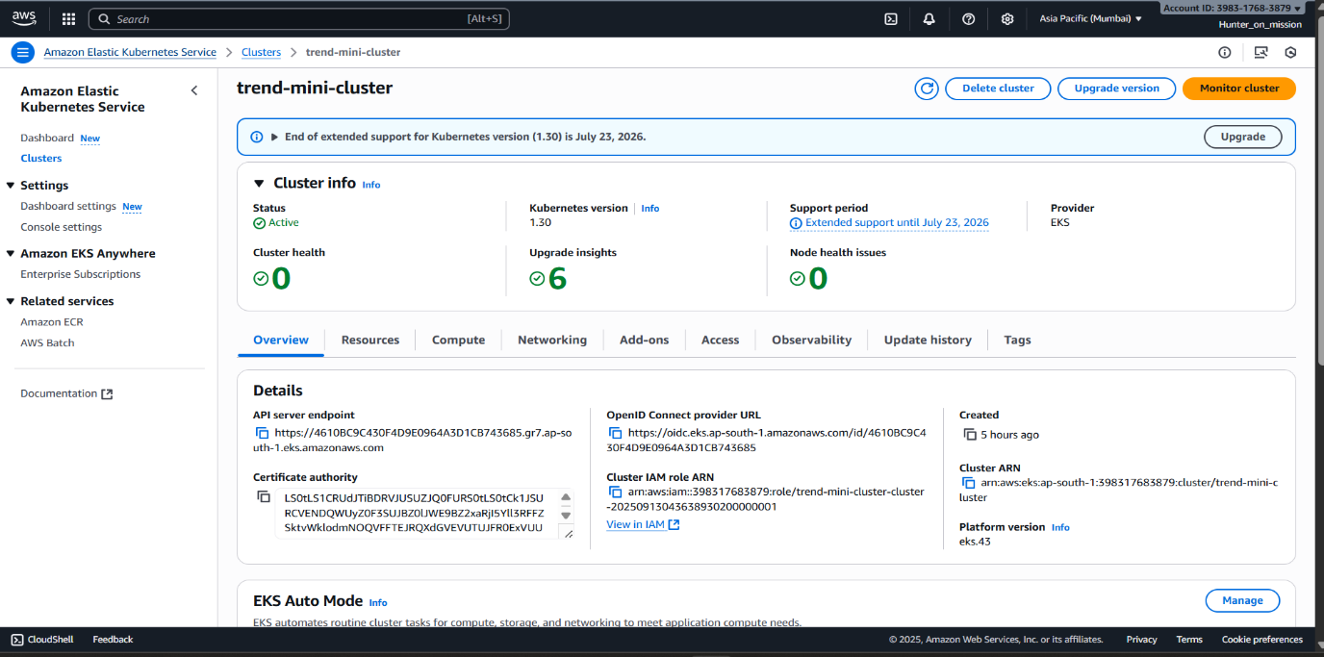19.cluster created in aws account**

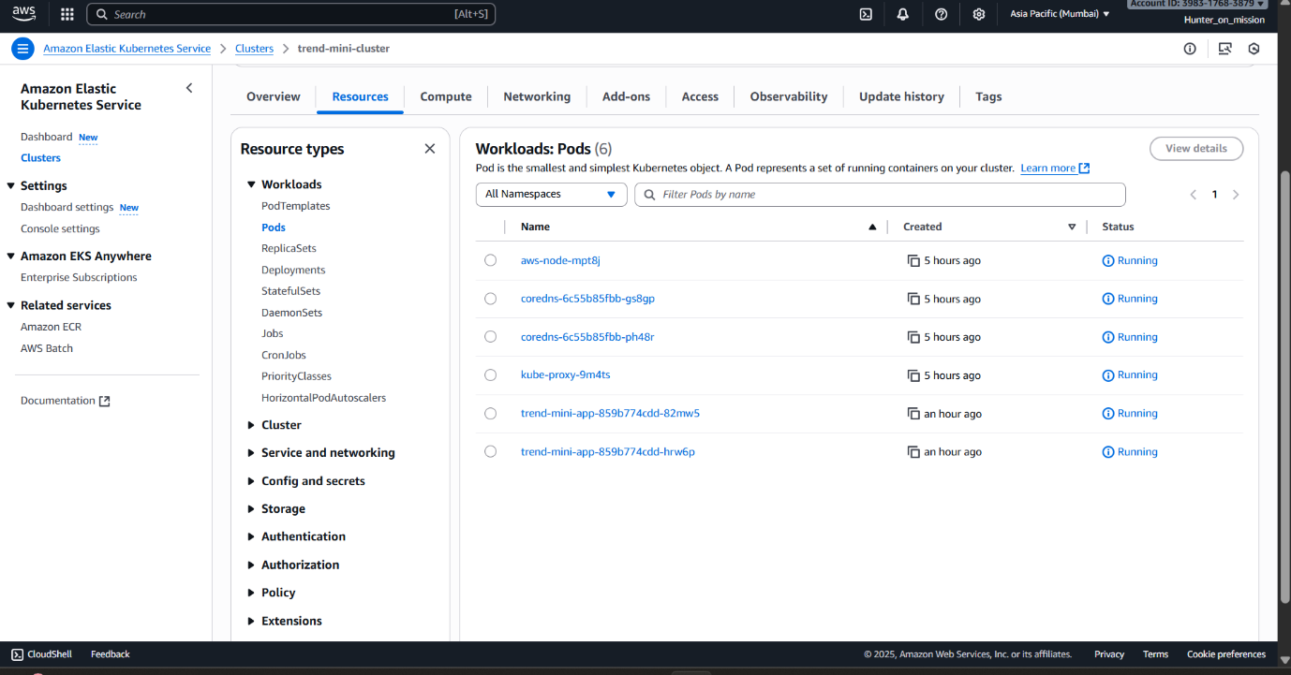**20. pods created in aws account**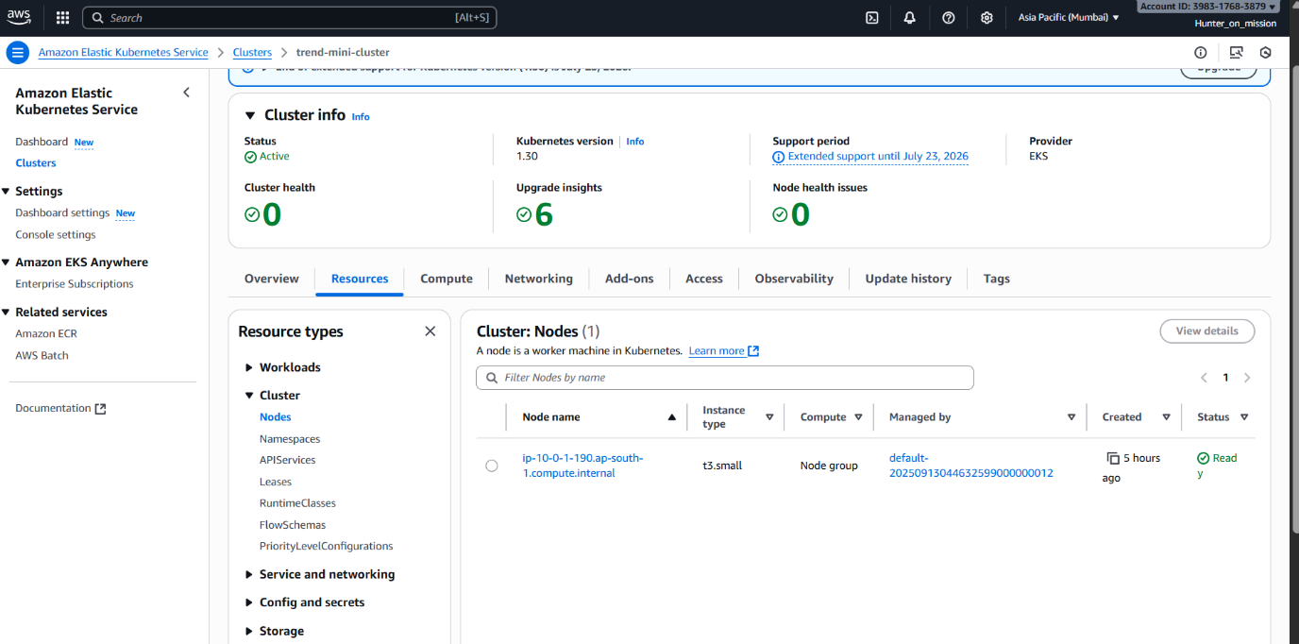

**20. node created in aws account**

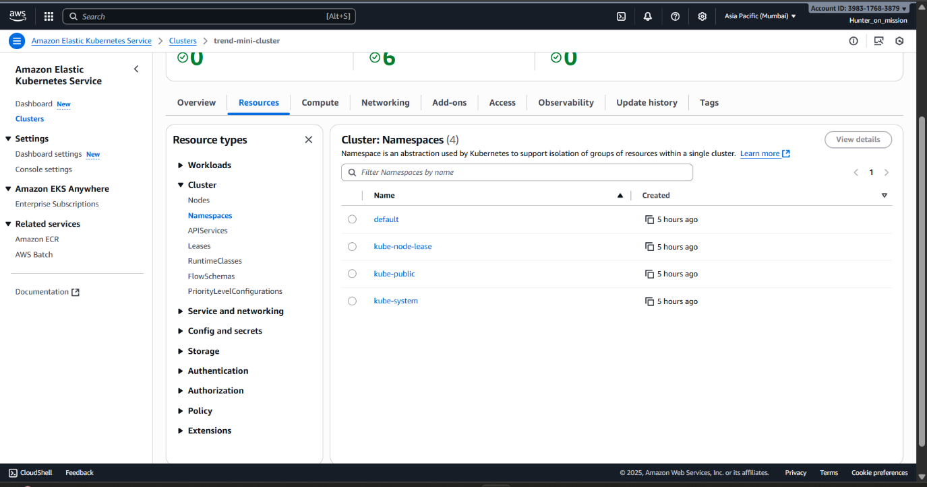

**21. namespace created in aws account**

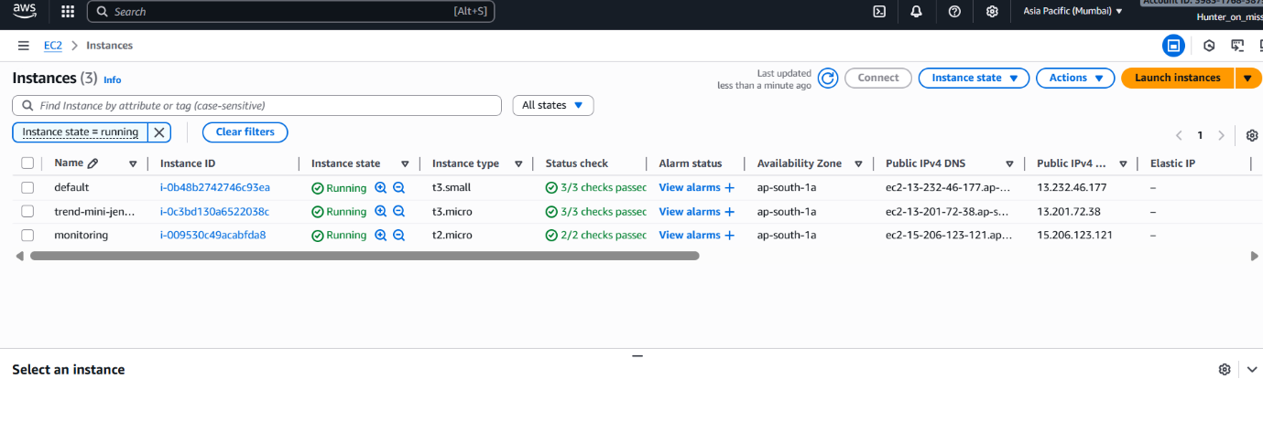

**22. EC2 machines where Jenkins and monitoring is running**

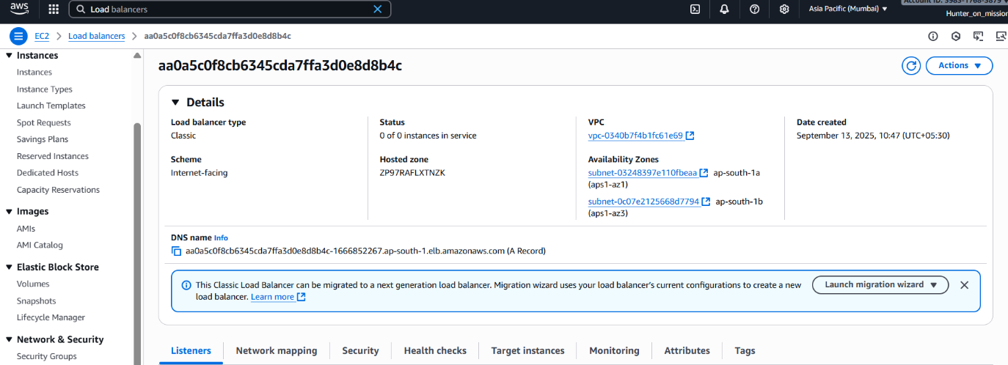

**23. Load balancer snapshot**



**24. project hosted with same DNS link**

**Step5: Monitoring**

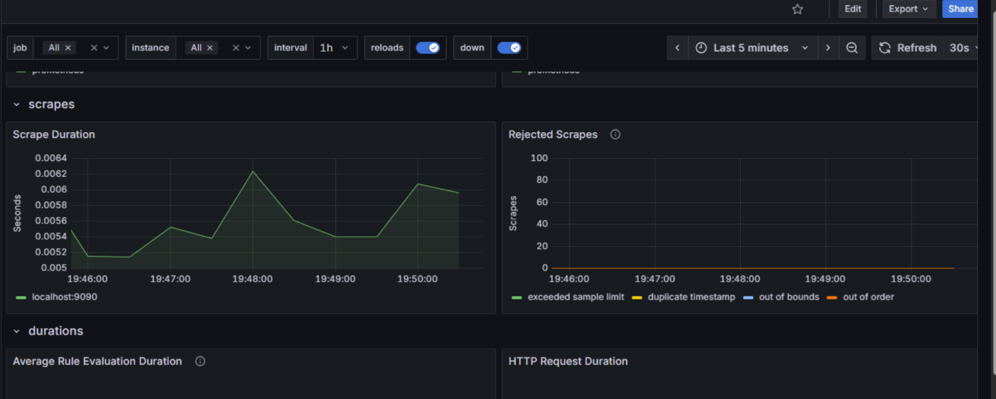

**25.Installed Grafana open source for monitoring system health**

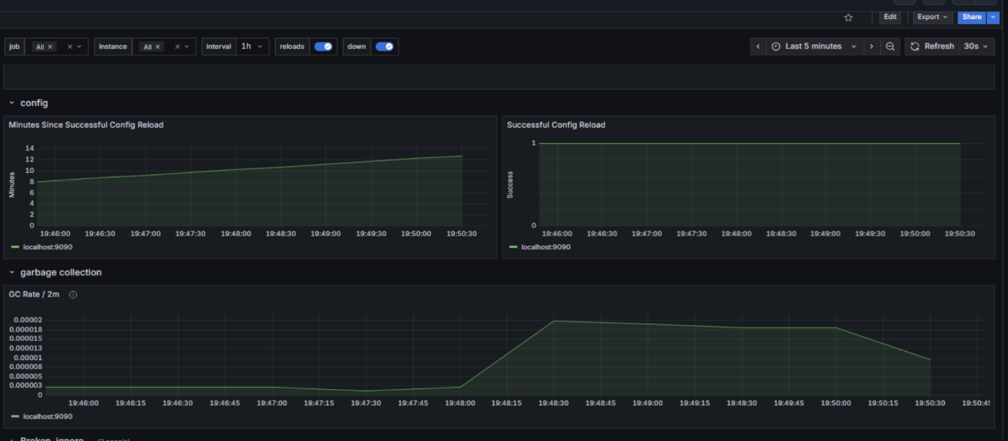

**25.1**

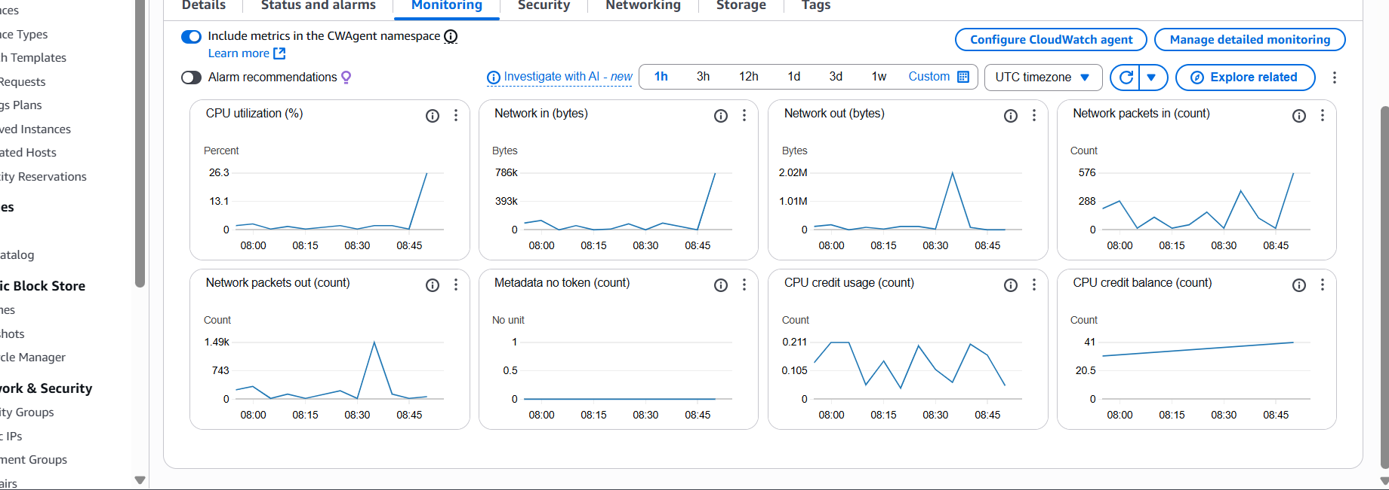

**26. Aws provide monitoring Log**

**Thank you**